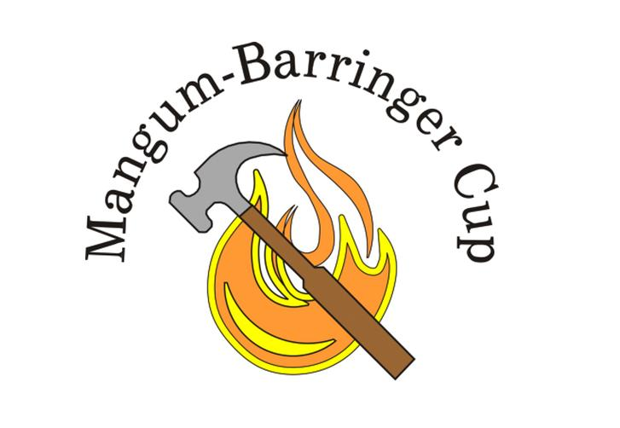
Mangum-Barringer Cup
October 1st-2nd, 2022

Hillandale Golf Course

2022 Honoree – General Harold E. Burch

Event: A Ryder Cup format event in memory of Jerry Mangum and Andy Barringer

Entry Fee: $125.00 must accompany entry form and includes course and cart fees, Friday evening dinner, Saturday lunch between matches; Sunday cookout after play.

Entries: Total entries must be divisible by 4 for equaling out teams. First come first serve basis.

Date: October 1st-2nd, 2022

Format: Saturday morning match will be Four-Ball (best ball of two); Saturday afternoon match will be modified Foursome (2 player team where each player hits a tee shot, selects best shot and alternates thereafter until ball is holed). Sunday morning Singles matches. Teams will be awarded 1 point for each match won and ½ point for each match tied. No deductions on losses. Team with the most points wins the Cup.

Teams: Will be picked Friday evening September 30th, at the Captain’s Dinner at Hillandale Golf Course. The Professional Staff at Hillandale Golf Course will select the Captains.

Functions: 6:30 PM Friday, September 30th, 2022, Captain’s Dinner, and Team Selections at the Hillandale Clubhouse. Potluck Dinner, Grilled Chicken provided, you bring a covered dish or dessert!

Friday Evening: 6:30 PM Captain’s Dinner and team selections at HGC
Bring your spouse or significant other!
Glow Ball Closest to Pin Contest for all M/B entrants!

Saturday Morning: Opening Four-Ball matches begin 8:30; Lunch 12:00-1:00; Afternoon Foursome Matches begin at approximately 1:00.

Sunday Morning: Singles Matches begin at 9:00 AM; Cookout after play at scoreboard area.

Awards: Winners receive a Mangum-Barringer Champions logoed shirt!

Name:_________________________________________ Phone#:________-________-___________ Shirt Size:_______

Email:_________________________________________ Handicap:______ Will you attend Friday’s dinner Y/N #_____

